**PROJECT REPORT ON FOOD ORDERING WEBSITE**

**in partial fulfillment for the award of the degree of**

**COMPUTER SCIENCE & ENGINEERING**

*Submitted By*

**SATYA SUBHAM MISHRA [220301120007]**

**SWASTI SWAGAT PALAURI [220301120018]**

**AYUSH ASHUTOSH [220301120040]**

**SMRUTI RANJAN SAHOO [220301120034]**

**OM PRAKASH SAHOO [220301120036]**

***Under the Guidance of***

**MS. Harapriya Senapati**

# 

**Asst. Professor, CSE**



DEPARTMENT OF CSE

**SCHOOL OF ENGINEERING AND TECHNOLOGY**

**BHUBANESWAR CAMPUS**

**CENTURION UNIVERSITY OF TECHNOLOGY AND MANAGEMENT**

**ODISHA**

**NOVEMBER,2023**

DEPARTMENT OF COMPUTER SCIENCE ENGINEERINGSCHOOL OF ENGINEERING AND TECHNOLOGY, BHUBANESWAR CAMPUS

# BONAFIDE CERTIFICATE

Certified that this project report “FOOD ORDERING WEBSITE”is the Bonafede work of “SATYA SUBHAM MISHRA (220301120034), SWASTI SWAGAT PALAURI (220301120018), AYUSH ASHUTOSH (220301120040), SMRUTI RANJAN SAHOO (220301120034), OM PRAKASH SAHOO (220301120036)” (who carried out the project work under my supervision. This is to further certify to the best of my knowledge, that this project has not been carried out earlier in this institute and the university.

**SIGNATURE**

**MS. Harapriya Senapati**

# Asst. Professor, CSE

*Certified that the above-mentioned project has been duly carried out as per the norms of the college and statutes of the university.*

**SIGNATURE**

**Mr. Raj Kumar Mohanta**

**HEAD OF THE DEPARTMENT**

DEPARTMENT SEAL

# DECLARATION

I hereby declare that the project entitled **“FOOD ORDERING WEBSITE”** submitted for the Project of 4TH semester, B. Tech in Computer Science and Engineering is my original work and the project has not formed the basis for the award of any Degree / Diploma or any other similar titles in any other University / Institute.

Signature of Student

Place:

Date:

# ACKNOWLEDGEMENTS

We wish to express our unbound and sincere gratitude to **MS. Harapriya Senapati**

, Department of Computer Science and Engineering, SOET, Bhubaneswar Campus, who guided me into the intricacies of this project nonchalantly with unbound magnanimity.

We thank **Prof. Raj Kumar Mohanta**, Head of the Department of Computer Science and Engineering, SOET, Bhubaneswar Campus and **Dr. Sujata Chakravarty**, Dean, School of Engineering and Technology for extending their support during Course of this investigation.

We are highly grateful to **MS. Harapriya Senapati** who evinced keen interest and invaluable support in the progress and successful completion of my project work.

We are indebted to **MS. Harapriya Senapati** for their constant encouragement, co-operation and help. Words of gratitude are not enough to describe the accommodation and fortitude which she has shown throughout our endeavour.

SATYA SUBHAM MISHRA [220301120007]

SWASTI SWAGAT PALAURI [220301120018]

AYUSH ASHUTOSH [220301120040]

SMRUTI RANJAN SAHOO [220301120034]

OM PRAKASH SAHOO [220301120036]

Place:

Date:

# ABSTRACT

The food industry has witnessed a significant shift towards online platforms for ordering food due to the convenience and accessibility they offer. In line with this trend, our project aims to develop a user-friendly food ordering website that enhances the overall experience for both customers and restaurant owners.

The key features of our website include a seamless user interface, intuitive navigation, and personalized recommendations based on user preferences and past orders. We prioritize user convenience by implementing a straightforward ordering process with multiple payment options and real-time order tracking.

Furthermore, our project integrates robust backend systems to streamline restaurant management tasks such as menu updates, order processing, and inventory management. Through effective data analytics, we empower restaurant owners with insights into customer preferences, peak ordering times, and popular dishes, enabling them to optimize their offerings and improve customer satisfaction.

# TABLE OF CONTENTS

**CHAPTER 1: INTRODUCTION 1**

* 1. BACKGROUND STUDY
  2. MOTIVATION
  3. CONTRIBUTIONS

**CHAPTER 2: METHODOLOGY 2**

2.1 OBJECTIVE

2.2 WORK- FLOW OF WEBSITE

**CHAPTER 3: SYSTEM REQUIREMENTS 5**

* 1. HARDWARE REQUIREMENTS

3.2 SOFTWARE REQUIREMENTS

**CHAPTER 4: RESULT 3**

4.1 WEBSITE VIEW

4.2 SNAPSHOTS

**CHAPTER 5: CONCLUSION AND FUTURE SCOPE 14**

5.1CONCLUSION

5.2FUTURE SCOPE

**REFERENCES**

# CHAPTER 1

## INTRODUCTION

A food ordering website is a platform that allows users to browse through a variety of restaurants, select dishes from their menus, and place orders for delivery or pickup. In today's fast-paced world, the demand for convenient and efficient ways to satisfy our culinary cravings is higher than ever. As dining-out options evolve, online food ordering platforms have emerged as a popular solution, providing customers with the ability to browse menus, place orders, and have delicious meals delivered right to their doorstep.

Our project aims to capitalize on this trend by developing a comprehensive food ordering website that seamlessly connects hungry consumers with a diverse array of restaurants and cuisines. Through intuitive design and user-friendly functionality, our platform will offer a streamlined experience, enabling users to effortlessly browse through menus, customize orders, and securely complete transactions online.

## Background Study

* Analyze the current landscape of food ordering websites, including major players, emerging trends, and market size.
* Identify key competitors and their market share.
* Examine any regulatory or legal considerations impacting the industry.
* Evaluate the user interface and design of popular food ordering websites.
* Study user journeys from landing on the site to completing an order.
* Assess the effectiveness of search functions, filtering options, and checkout processes.
* Consider accessibility and mobile responsiveness.
* Understand the technology stack behind food ordering websites, including frontend, backend, and database systems.
* Investigate the use of artificial intelligence and machine learning for personalized recommendations, route optimization, or fraud detection.
* Assess the scalability and reliability of the platform, especially during peak hours.

## Motivation

Firstly, it addresses the growing demand for convenient and efficient ways to order food, especially in the digital age where online platforms dominate various aspects of life. Such a project aims to streamline the process of food ordering, offering customers a user-friendly interface to browse through menus, place orders, and make payments with ease. Additionally, it provides an avenue for restaurants to expand their reach beyond traditional brick-and-mortar establishments, tapping into a broader customer base and potentially increasing revenue. Moreover, in the wake of global events like the COVID-19 pandemic, contactless delivery and online ordering have become increasingly essential for ensuring safety and adhering to social distancing measures. Thus, the food ordering website project not only meets the evolving needs of consumers but also aligns with the changing landscape of the hospitality industry, ultimately enhancing convenience, accessibility, and safety for both customers and businesses alike.

## 1.3 Contributions

The food ordering website project involved a collaborative effort where each team member played a vital role in its success. As a developer, my contribution encompassed designing and implementing the user interface, ensuring seamless navigation and an intuitive ordering process. I utilized my programming skills to integrate essential functionalities like secure payment gateways and real-time order tracking. Additionally, I actively participated in brainstorming sessions, offering innovative solutions to challenges and refining features based on user feedback. Through effective communication and coordination with team members, we were able to meet deadlines and deliver a high-quality product that enhances the dining experience for customers and streamlines operations for restaurants.

# CHAPTER 2

## METHODOLOGY

**2.1 Objective**

The objective of our food ordering website project is to create a user-friendly platform that seamlessly connects hungry customers with a variety of local restaurants, offering a convenient and efficient way to order food online. Through intuitive design and robust functionality, we aim to enhance the dining experience by providing users with a wide selection of menu options, customizable orders, and seamless payment processing. Our goal is to streamline the ordering process, making it easy for customers to browse, select, and receive their desired meals while also providing restaurants with a reliable platform to showcase their offerings and efficiently manage incoming orders. Ultimately, we seek to foster a mutually beneficial ecosystem where both customers and restaurants can enjoy the benefits of online food ordering.

Top of Form

**2.2 WORK-FLOW OF WEBSITE**

## CHAPTER 3

## SYSTEM REQUIREMENTS

## 2.3 Software Platforms(A) Xampp

Xampp is a free and open-source cross-platform web server solution stack package developed by Apache Friends. It is a collection of software tools bundled together to create a local web server environment for testing and development purposes. XAMPP stands for Cross-Platform (X), Apache (A), MariaDB or MySQL (M), PHP (P), and Perl (P).

XAMPP includes Apache HTTP Server, MySQL database, PHP and Perl scripting languages, and phpMyAdmin for managing MySQL databases. It also includes OpenSSL for secure connections, FileZilla FTP server and client, Mercury Mail Transport System for sending emails, and Tomcat for Java Servlets and JavaServer Pages (JSP).

One of the main advantages of using XAMPP is that it allows developers to create a local web server environment on their own computer, which makes it easy to develop and test web applications without the need for an internet connection or a live server. Additionally, XAMPP is easy to install and configure, and it is available for Windows, Linux, and Mac OS X.

However, it is important to note that XAMPP is not recommended for use in production environments. It is primarily intended for development and testing purposes only. When deploying web applications in a live environment, it is recommended to use a dedicated web server instead.

Overall, XAMPP is a powerful and convenient tool for web developers who want to create and test web applications on their local computers. It provides an easy-to-use and flexible platform for building and deploying web applications, making the development process faster and more efficient.

## (B)Visual Studio Code

VS Code is a free and open-source source-code editor developed by Microsoft for Windows, Linux, and macOS. It is designed to be highly customizable and extensible, with a wide range of features that make it a popular choice among developers.

One of the key features of Visual Studio Code is its ability to support a wide range of programming languages and file formats. It comes with built-in support for languages such as JavaScript, TypeScript, Python, C++, and many more, as well as support for various file formats including HTML, CSS, JSON, and Markdown. Additionally, VS Code has a large library of extensions that can be used to add support for even more languages and file types.

Another notable feature of Visual Studio Code is its integrated debugger. With this feature, developers can easily set breakpoints, inspect variables, and step through their code to help identify and fix issues in their programs.

Visual Studio Code also includes support for version control systems such as Git, making it easy for developers to manage their code and collaborate with others on their projects. In addition, it offers integrated terminal support, which allows developers to run command-line tools directly within the editor.

One of the things that sets Visual Studio Code apart from other code editors is its strong community and ecosystem. Because it is open-source, developers are able to contribute to the project and create their own extensions, themes, and other tools that can be used to enhance the editor's functionality.

Overall, Visual Studio Code is a powerful and versatile code editor that offers a wide range of features and extensibility options. Its ability to support multiple languages and file formats, integrated debugger and version control support, and strong community make it a popular choice for developers of all levels.

# CHAPTER 4

## RESULTS

## 

**4.1 WEBSITE VIEW**



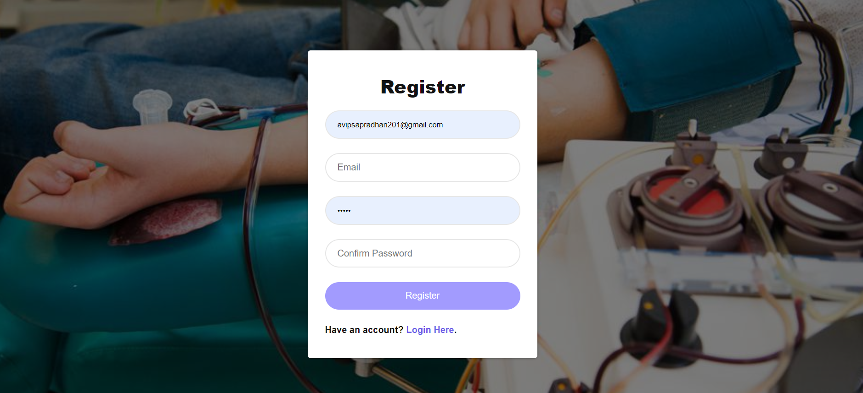



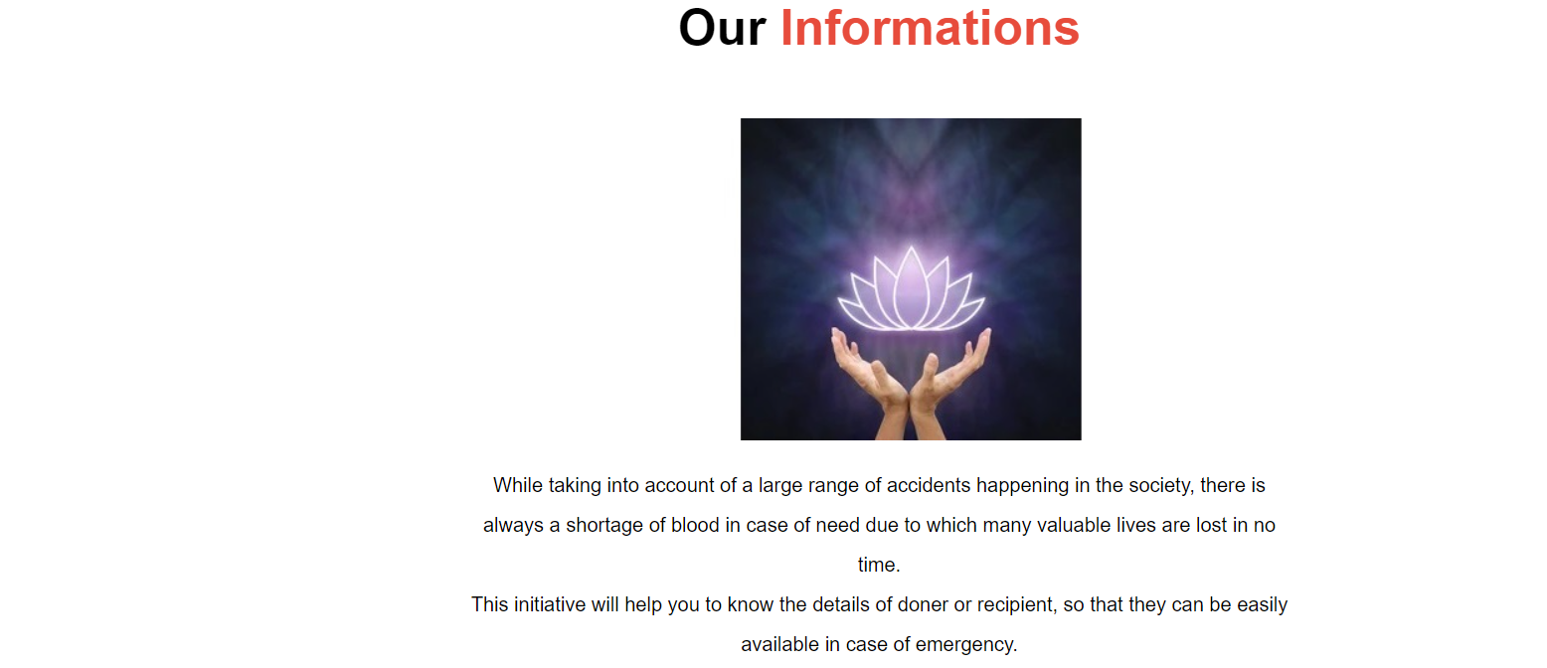

### 

### 

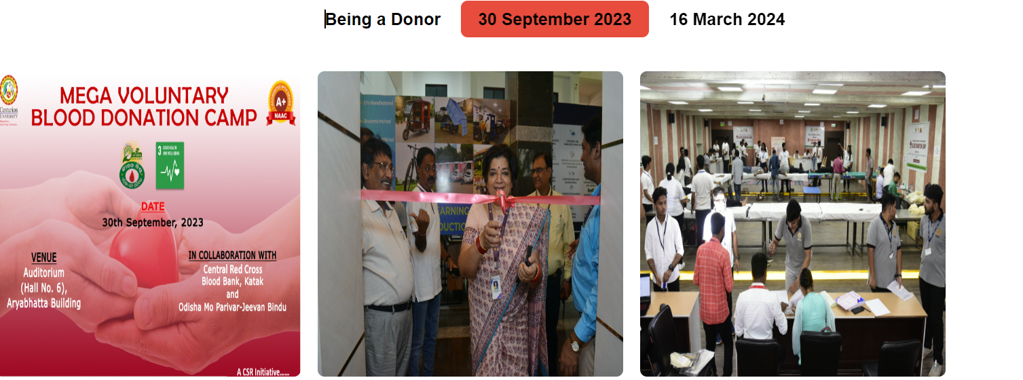

### 

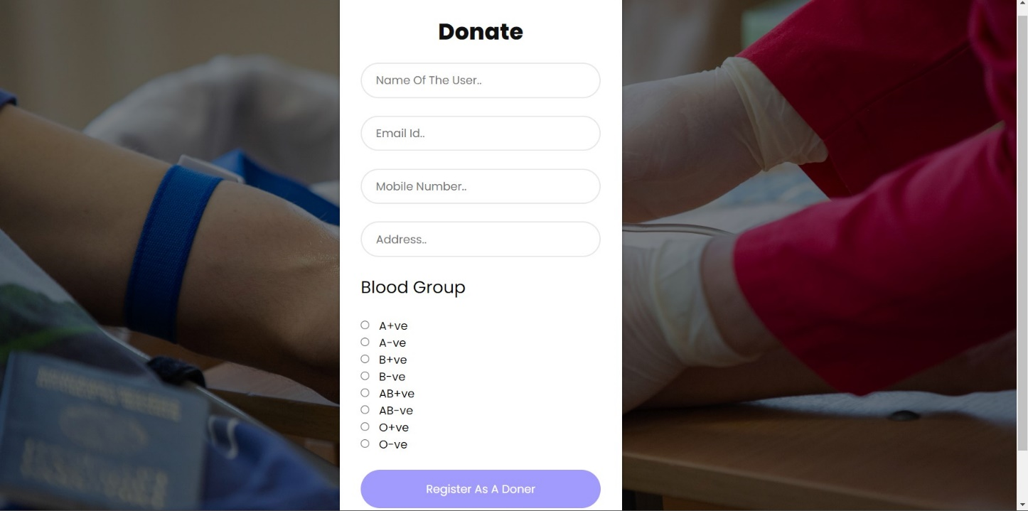

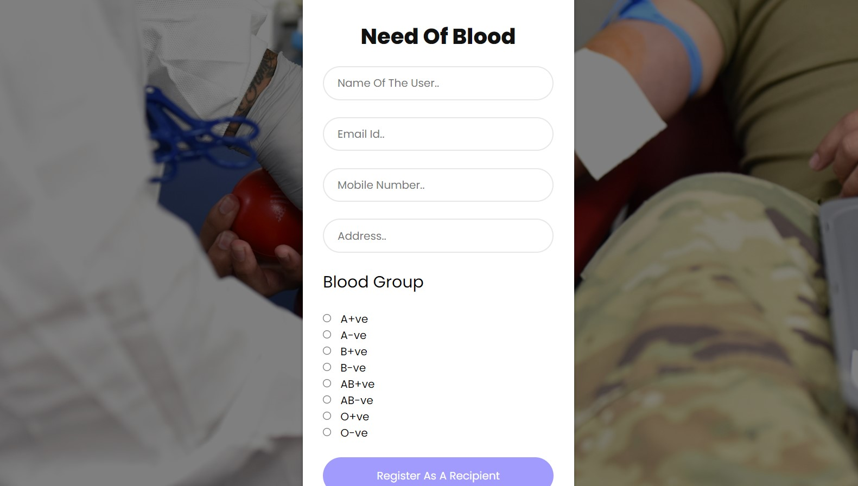

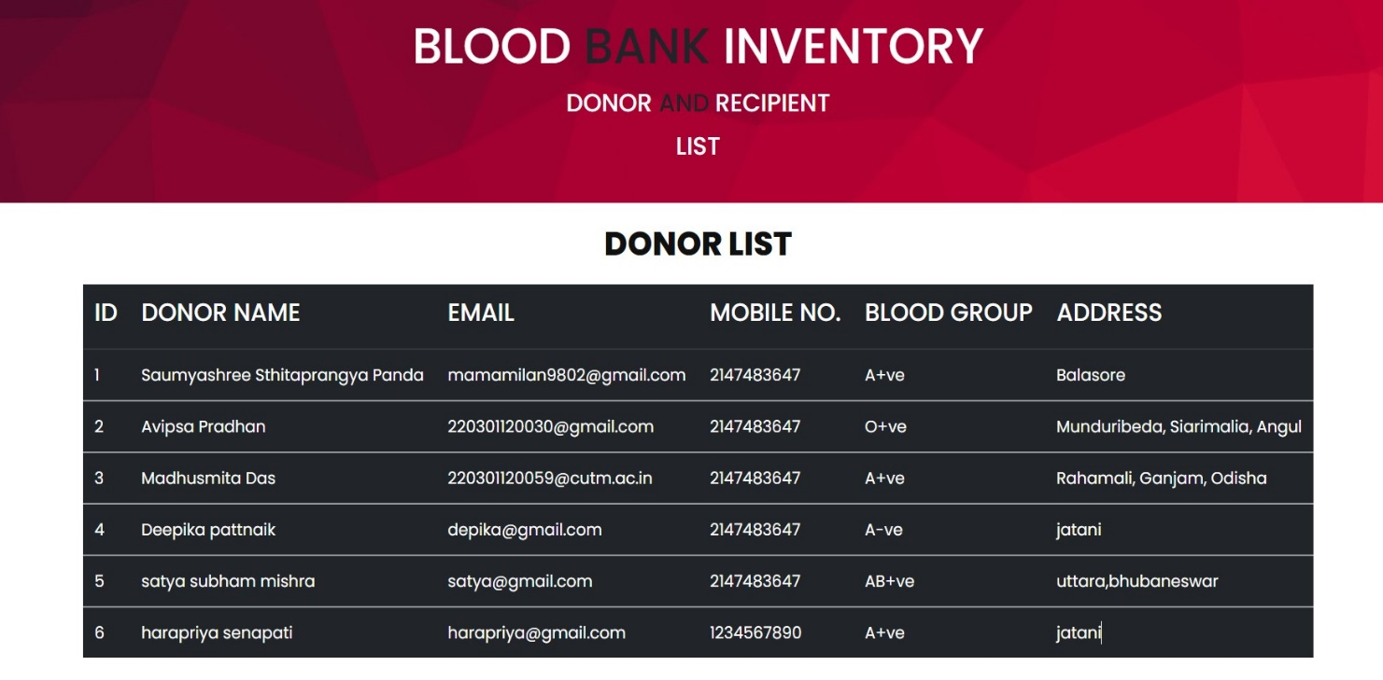

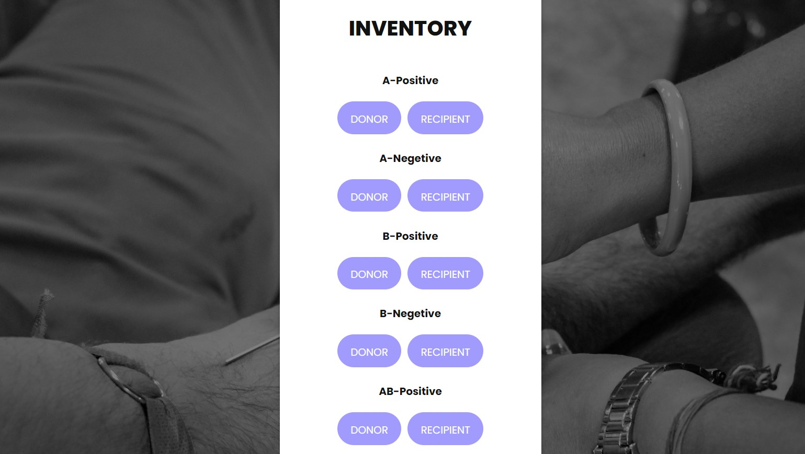

### CHAPTER 5

### 5.1 CONCLUSION

The food ordering website project presents a comprehensive solution to streamline the process of ordering food online, catering to the modern lifestyle where convenience is paramount. Through intuitive user interfaces and seamless navigation, users can browse diverse menus, place orders, and make payments effortlessly. The incorporation of features such as user profiles, order history, and customizable preferences enhances user experience and fosters loyalty. Moreover, the integration of secure payment gateways ensures the safety of transactions. Overall, the food ordering website project promises to revolutionize the way people interact with food establishments, offering unparalleled convenience and efficiency in the digital age.

4.1 Future Scope

The future scope for a food ordering website project is promising, with several avenues for growth and innovation. Integrating advanced AI algorithms can enhance user experience by personalizing recommendations based on past orders and preferences. Incorporating augmented reality (AR) technology can allow customers to visualize menu items before placing an order, enhancing engagement and reducing order errors. Furthermore, expanding the platform to include partnerships with local farms and sustainable food suppliers can cater to the growing demand for eco-friendly and locally sourced ingredients. Leveraging blockchain technology for transparent supply chain management can build trust with consumers concerned about food safety and authenticity. Additionally, embracing mobile app development and optimizing for seamless mobile ordering experiences can tap into the increasing trend of on-the-go dining preferences. Overall, the future of food ordering websites lies in continual innovation, catering to evolving consumer needs, and leveraging emerging technologies to deliver unparalleled convenience and satisfaction.

# ASSESSMENT External:

|  |  |  |  |  |
| --- | --- | --- | --- | --- |
| **SL NO** | **RUBRICS** | **FULL MARK** | **MARKS**  **OBTAINED** | **REMARK**  **S** |
| 1 | Understanding the relevance, scope and dimension of the project | 10 |  |  |
| 2 | Methodology | 10 |  |  |
| 3 | Quality of Analysis and Results | 10 |  |  |
| 4 | Interpretations and Conclusions | 10 |  |  |
| 5 | Report | 10 |  |  |
|  | **Total** | **50** |  |  |

**Date: Signature of the Faculty**

**COURSE OUTCOME (COs) ATTAINMENT**

* + **Expected Course Outcomes (COs):**

**(Refer to COs Statement in the Syllabus)**

Developed a foundational understanding of basic probability concepts and statistical principles.

**______________________________________________________________________**

**___**

**______________________________________________________________________** **__________**

**______________________________________________________________________ __________**

* + **Course Outcome Attained:**

**How would you rate your learning of the subject based on the specified COs?**



**1 2 3 4 5 6 7 8 9 10**   **LOW HIGH**

* + **Learning Gap (if any):**

______________________________________________________________________

_____

______________________________________________________________________ _____

______________________________________________________________________

_____

______________________________________________________________________ _____

* + **Books / Manuals Referred:**

**______________________________________________________________________**

**______________________________________________________________________ __________**

**______________________________________________________________________** **__________**

**______________________________________________________________________ __________**

**Date: Signature of the Student**

* + **Suggestions / Recommendations:**

**(By the Course Faculty)**

**______________________________________________________________________**

**______________________________________________________________________ __________**

**______________________________________________________________________** **__________**

**______________________________________________________________________**

**__________**

**Date: Signature of the Faculty**